- BIRD-FLY OR NOT
AIM
To write a Prolog program to determine whether a particular bird can fly or not using facts, rules, and queries.
OBJECTIVE
- To store bird information as Prolog facts.
- To identify birds that cannot fly.
- To use a rule to determine the flying ability of a bird.
- To execute queries for checking whether a particular bird can fly.
ALGORITHM
- Start.
- Define the list of birds as facts.
- Define birds that cannot fly.
- Create the rule can_fly(Bird).
- Enter the name of a bird as a query.
- Check whether the bird is present in the database.
- If the bird is not in the cannot_fly list, return true.
- Otherwise, return false.
- Display the result.
- Stop.
FLOWCHART
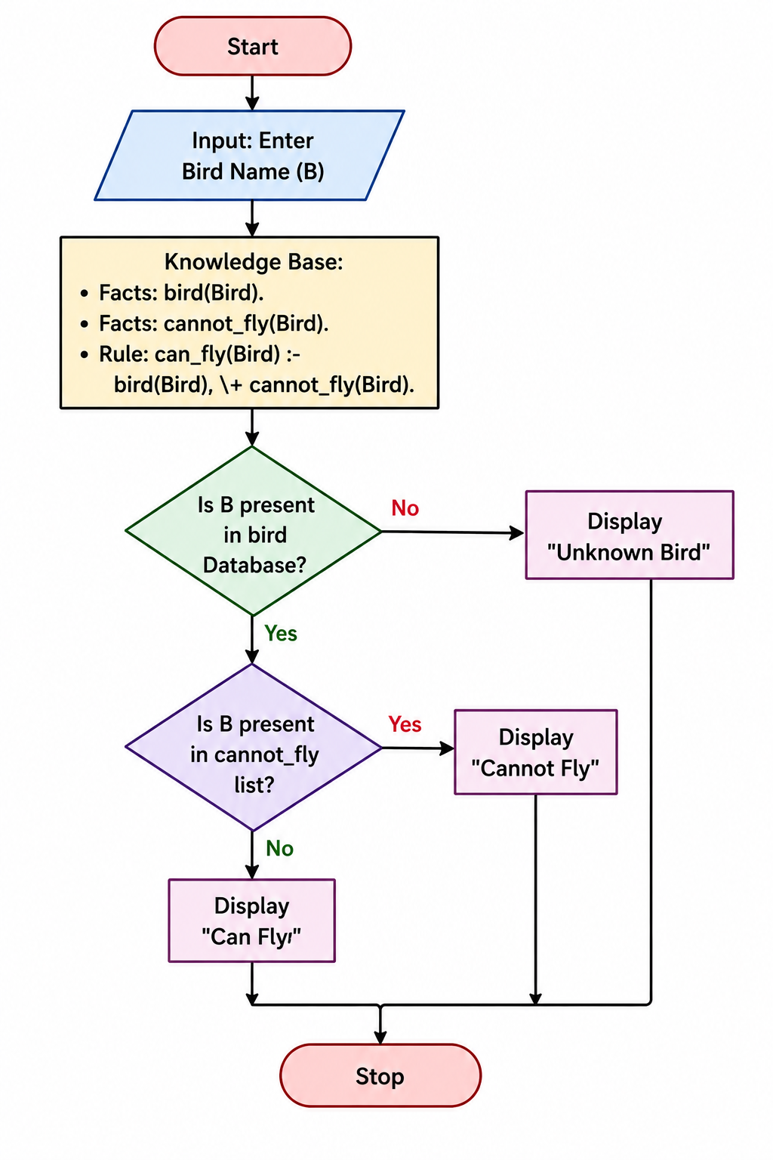
CODE:
bird(eagle).
bird(parrot).
bird(pigeon).
bird(sparrow).
bird(penguin).
bird(ostrich).
cannot_fly(penguin).
cannot_fly(ostrich).
can_fly(Bird) :-
bird(Bird),
\+ cannot_fly(Bird).
OUTPUT
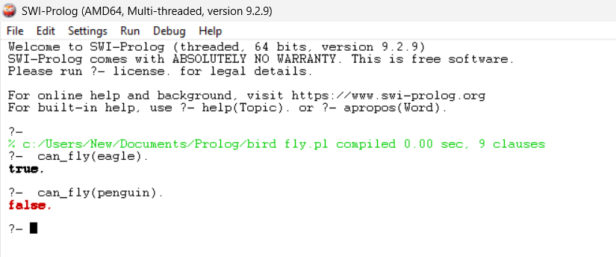
RESULT:
Thus, the Prolog program was successfully implemented to determine whether a particular bird can fly or not, and the required queries produced the expected results.

